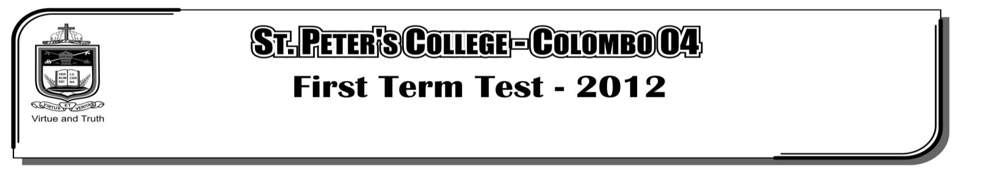

**FIRST TERM TEST - 2019**

**GRADE 11 – Physical Education**

**Part I**

**Select correct answers.**

01. This physical fitness component test displayed in the picture is,

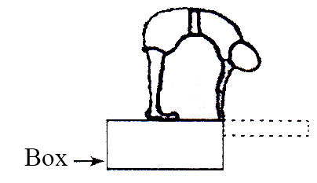

i. Strength ii. Co-ordination

iii. Flexibility iv. Agility

02. What is the number of warnings given if a foul start is made in a running event according to I. A. A. F.

i. 1 ii. 2 iii. 3 iv. 4

03. The following are some skills of a particular sport its?

³ Service

³ Receiving

³ Setting

³ Spiking

³ Blocking

i. Badminton ii. Table Tennis iii. Tennins iv. Volleyball

04. The diagram below shows how a player starts his track event. What should be his event ?

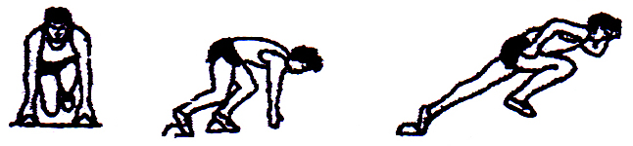

i. 100 m and 200 m ii. 100 m and 1500 m

iii. 200 m and 800 m iv. 400 m and 800 m

05. This diagram shows

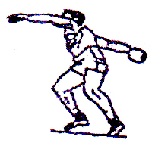

i. A figure of throwing a shot putt

ii. A figure of balling in cricket

iii. A figure of service in volleyball

iv. A figure of throwing discuss

06. These equipment are used for ?

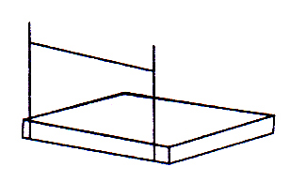

i. Pole vault

ii. High jump

iii. Hurdles

iv. Gymnastic

³ Answer the questions 7 – 13 with the help of diagram below.

A…………….

Throws

D…………….

Discuss throws

E…………….

F…………….

G…………….

B…………….

Horizontal

C…………….

Long Jump

H…………….

High Jump

I…………….

07. According to the diagram what is the suitable for A ?

i. Athletic events ii. Track and field events

iii. Track events iv. Field events

08. What is suitable for B ?

i. Short distance ii. Middle distance

iii. Crouch starts iv. Jumps

09. What is suitable for C ?

i. 100 m ii. Hop scoch iii. Zig Zag run iv. Vertical Jump

10. What is suitable for D ?

i. Throwing hammer ii. Javline iii. Throwing iv. Shot putt

11. What are the suitable answers for the E , F in order ?

i. Throwing shot putt and hammer ii. Javline and throwing balls

iii. Hammer and throwing balls iv. Hammer and Javelin

12. What is the most suitable answer for G ?

i. Batton ii. Hurdles iii. Javelin iv. Shot putt

13. Suitable for H and I ?

i. Pole valte and triple jump ii. Triple jump and Hop scoch

iii. Triple jump and long jump iv. Triple jump and pole valte

14. The starter of all rounds in volleyball is called ?

i. The server ii. The libero iii. The receiver iv. The attacker

15. How many methods are there for a “throw in” in football ?

i. 3 ii. 4 iii. 2 iv. 1

16. Number of referees in a game of football ?

i. 2 ii. 3 iii. 1 iv. 4

17. Which position is the ball “out of play” in football?

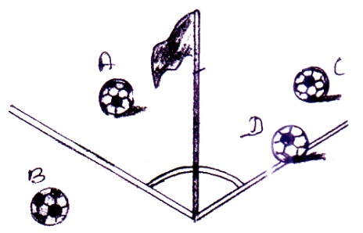

i. A ii. B

iii. C iv. D

18. The law of the off – side position will not be applicable if a player receives the ball directly from,

i. Penalty ii. Throw out iii. Goal kick iv. Free kick

19. Which is not a penalty given to the offences in netball is?

i. Free pass ii. Penatly pass

iii. Tossing the ball up between two players iv. Penalty kick

20. No of referees in a game of netball ?

i. 1 ii. 2 iii. 3 iv. 4